Tugas 1  
PROYEK SAINS DATA

Diajukan untuk memenuhi salah satu matakuliah Kecerdasan Bisnis

yang diampu oleh:

*Eka Mala Sari Rochman, S.Kom M.Kom*



**Oleh:**

Muhammad Ardan Ratama (210411100077)

PROGRAM STUDI TEKNIK INFORMATIKA

FAKULTAS TEKNIK

UNIVERSITAS TRUNOJOYO MADURA

**Parkinson Disease Detection**

Dataset ini terdiri dari 11 variabel yaitu MDVP:Fo(Hz), MDVP:Fhi(Hz), MDVP:Flo(Hz), MDVP:Jitter(%), MDVP:Jitter(Abs), MDVP:RAP, MDVP:PPQ, Jitter:DDP MDVP:Shimmer, MDVP:Shimmer(dB), Shimmer:APQ3, Shimmer:APQ5, MDVP:APQ, Shimmer:DDA, NHR,HNR, status, RPDE, D2, DFA, spread1, spread2, PPE





1. MDVP:Fo(Hz) - Rata-rata frekuensi dasar vokal
2. MDVP:Fhi(Hz) - Frekuensi dasar vokal maksimum
3. MDVP:Flo(Hz) - Frekuensi dasar vokal minimum
4. MDVP: Jitter(%),MDVP:Jitter(Abs),MDVP:RAP,MDVP:PPQ,Jitter:DDP - Beberapa  
   ukuran variasi frekuensi dasar
5. MDVP:Shimmer,MDVP:Shimmer(dB),Shimmer:APQ3,Shimmer:APQ5, MDVP:APQ,Shimmer:DDA - Beberapa ukuran variasi amplitudo
6. NHR,HNR - Dua ukuran rasio kebisingan terhadap komponen nada dalam  
   status suara - Status kesehatan subjek (satu) - Parkinson, (nol) – sehat
7. RPDE, D2 - Dua ukuran kompleksitas dinamis nonlinier
8. DFA - Eksponen penskalaan fraktal sinyal
9. spread1,spread2,PPE - Tiga ukuran nonlinier dari variasi frekuensi fundamental
10. **Analisis data menggunaka Power BI**

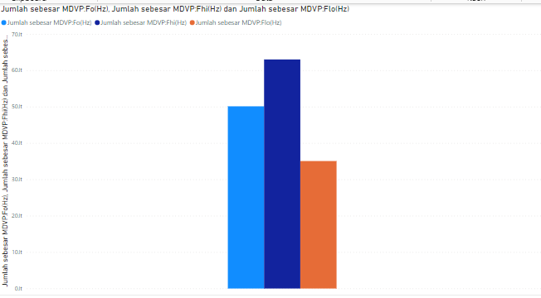

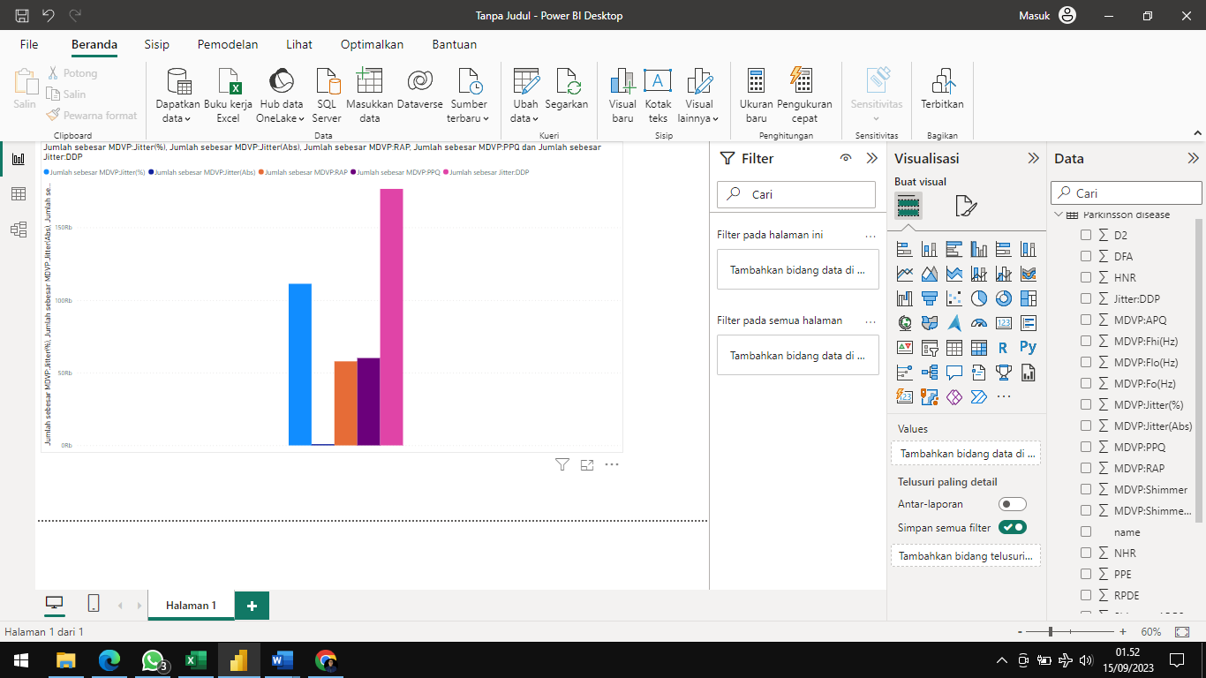

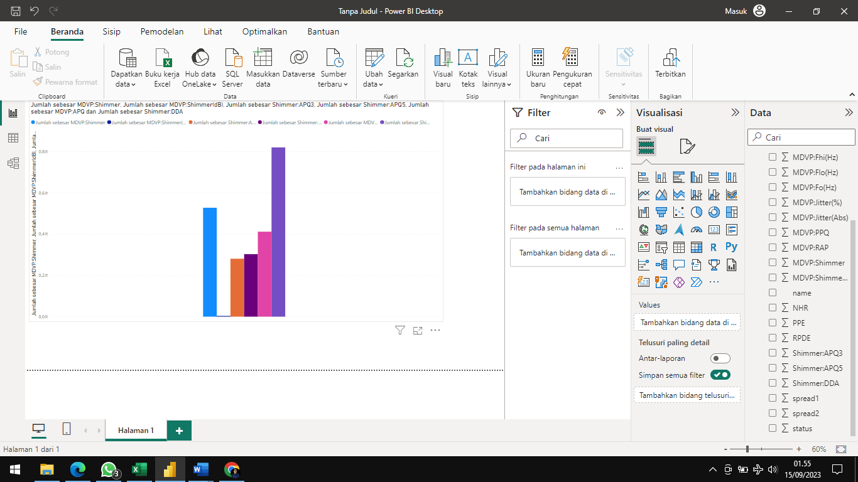

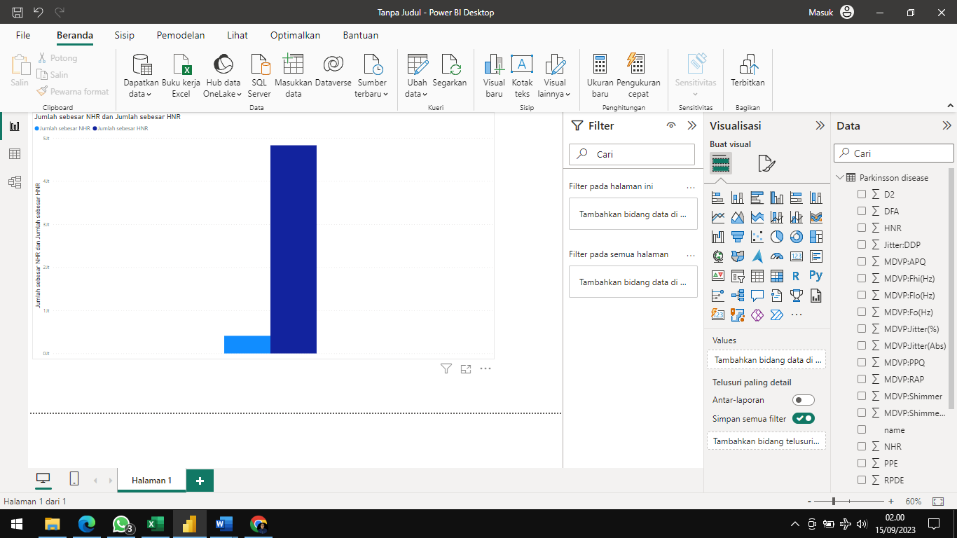

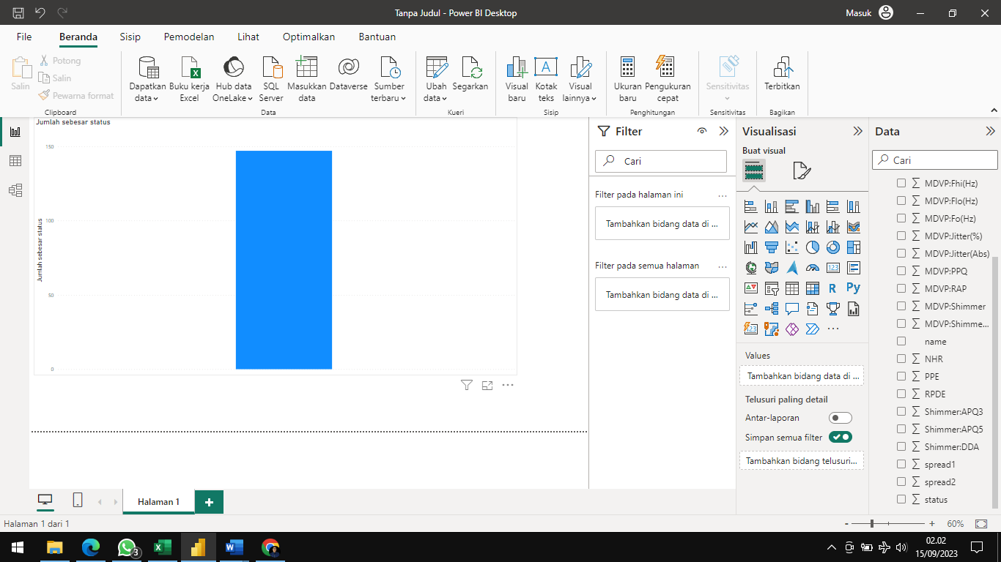

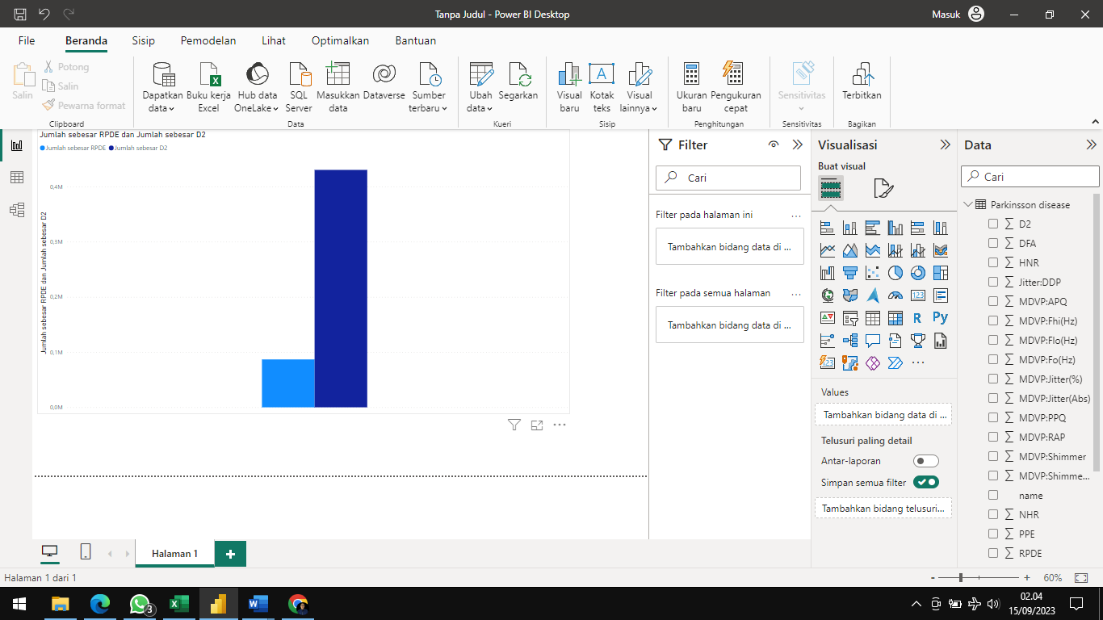

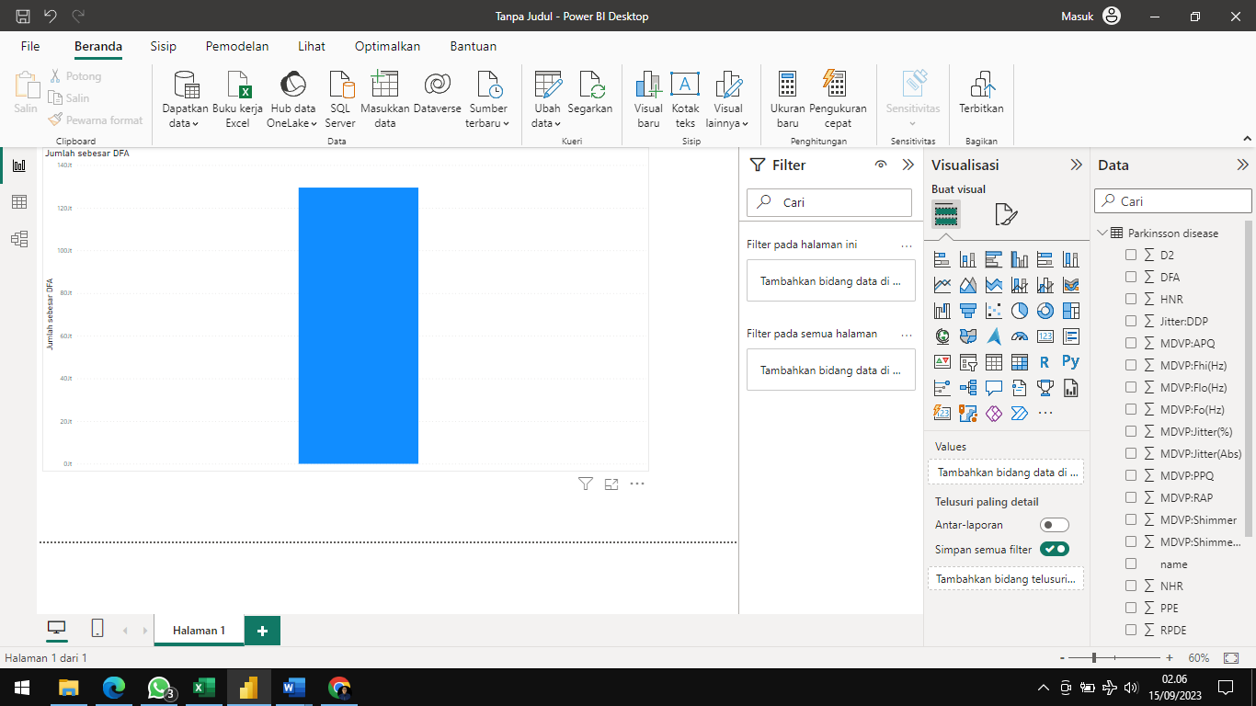

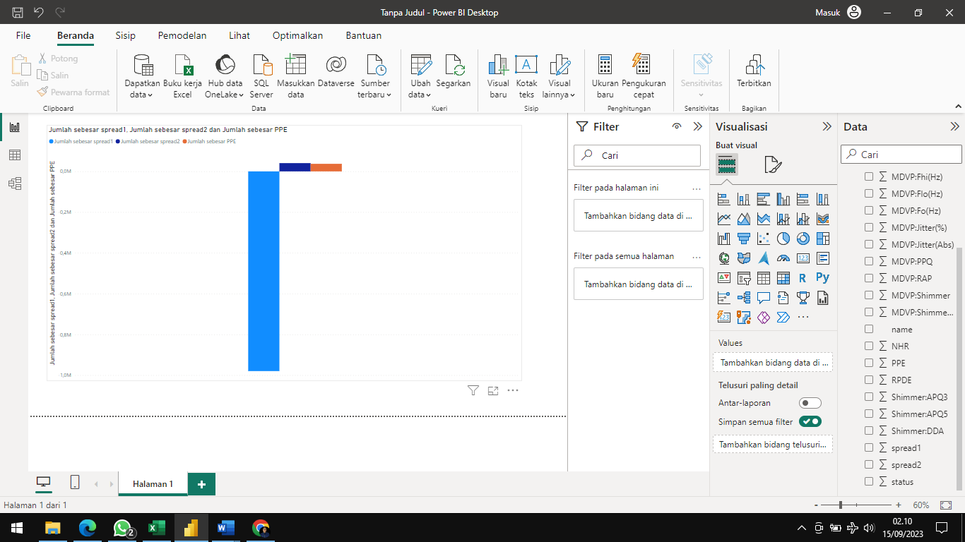

1. **Analisis Parameter**
2. MDVP:F0 (Hz) Average vocal fundamental frequency
3. MDVP:Fhi (Hz) Maximum vocal fundamental frequency
4. MDVP:Flo (Hz) Minimum vocal fundamental frequency
5. MDVP:Jitter(%) MDVP jitter in percentage
6. MDVP:Jitter(Abs) MDVP absolute jitter in ms
7. MDVP:RAP MDVP relative amplitude perturbation
8. MDVP:PPQ MDVP five-point period perturbation quotient
9. Jitter:DDP Average absolute difference of differences between jitter cycles
10. MDVP:Shimmer MDVP local shimmer
11. MDVP:Shimmer(dB) MDVP local shimmer in dB
12. Shimmer:APQ3 Three-point amplitude perturbation quotient
13. Shimmer:APQ5 Five-point amplitude perturbation quotient
14. MDVP:APQ11 MDVP 11-point amplitude perturbation quotient
15. Shimmer:DDA Average absolute differences between the amplitudes of consecutive periods
16. NHR Noise-to-harmonics ratio
17. HNR Harmonics-to-noise ratio
18. RPDE Recurrence period density entropy measure
19. D2 Correlation dimension
20. DFA Signal fractal scaling exponent of detrended fluctuation analysis
21. Spread1 Two nonlinear measures of fundamental
22. Spread2 Frequency variation
23. PPE Pitch period entropy
24. **Cleaning Data**

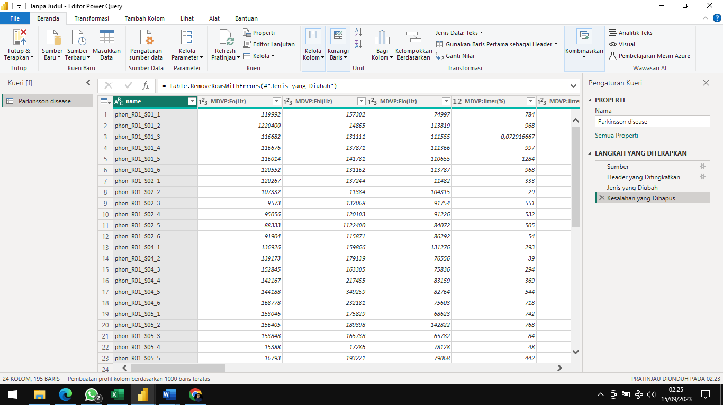

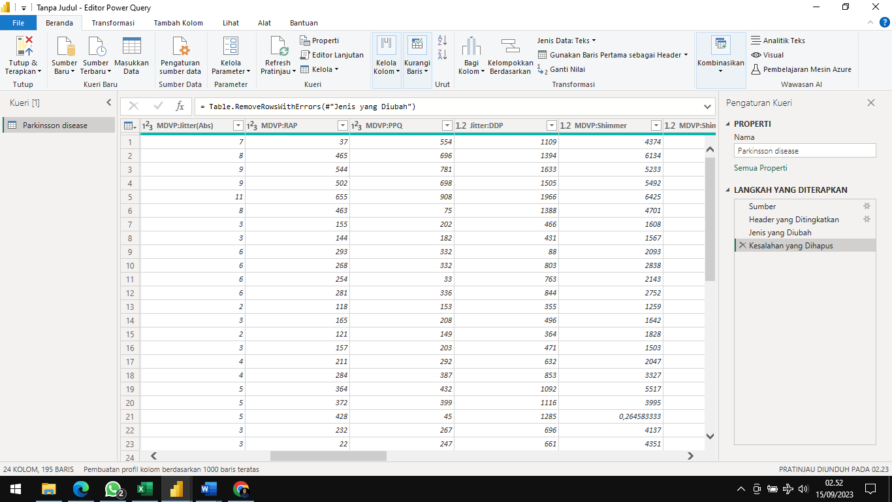

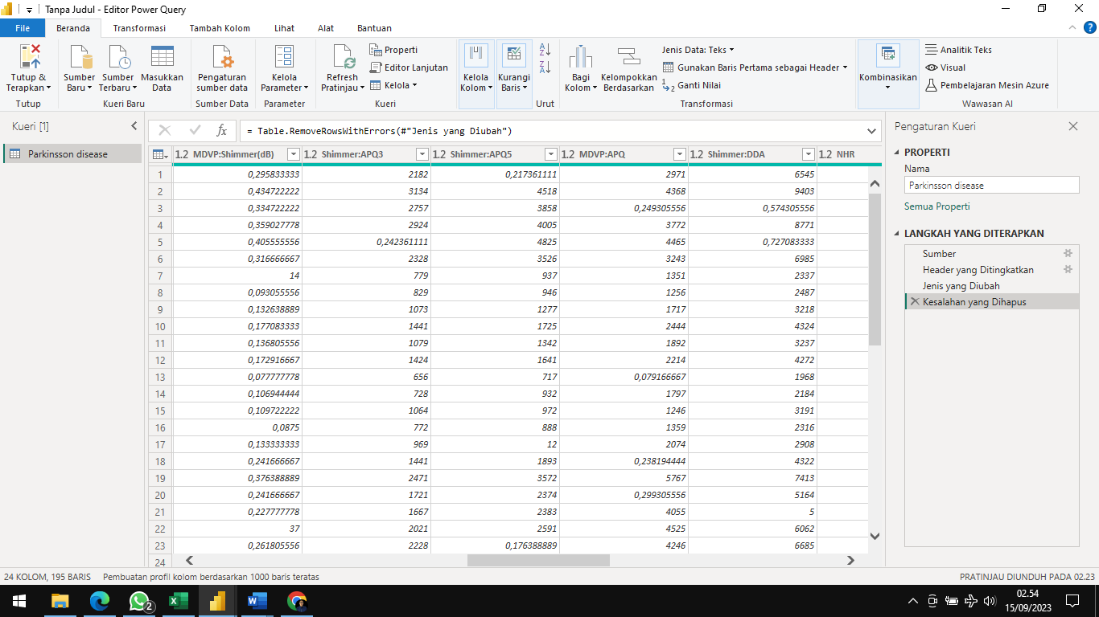

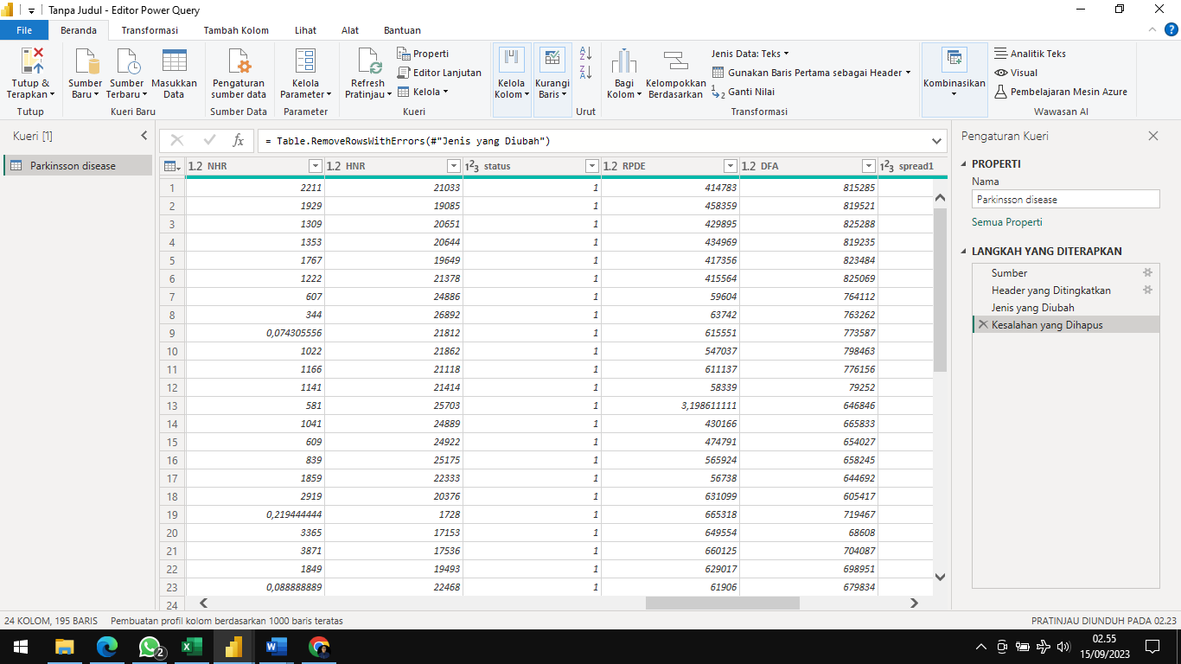

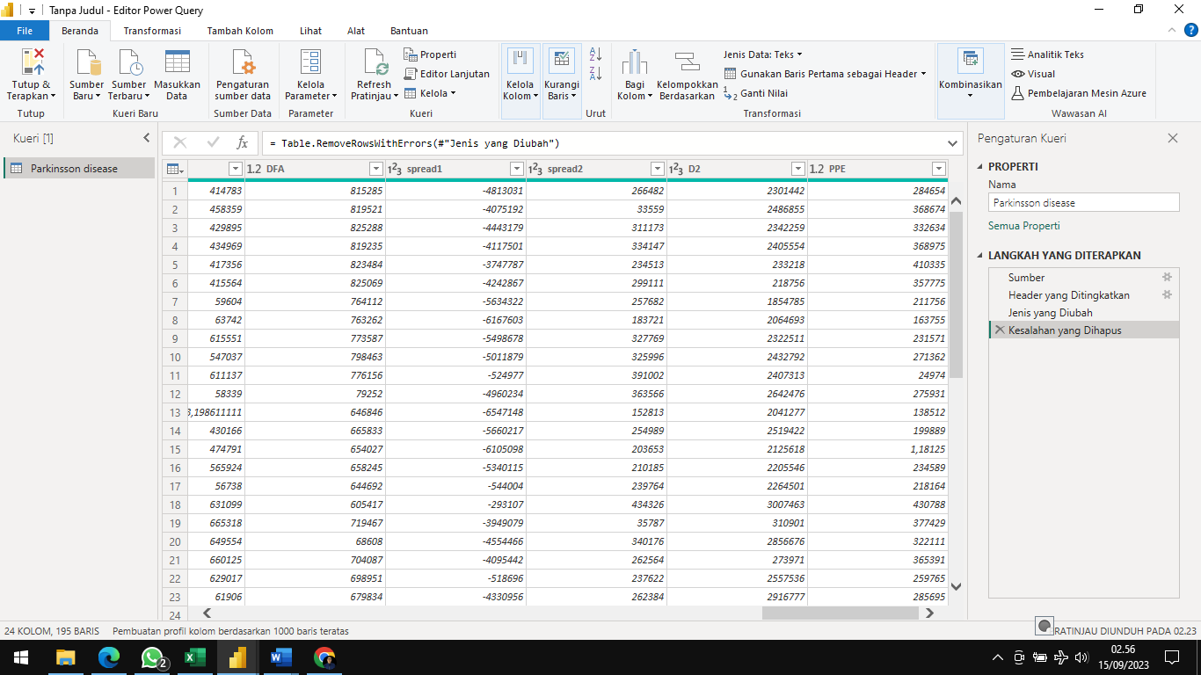

1. **Missing Data**

Tidak terdapat Missing Data pada Parkinson Disease Detection